Titration Curves

As part of this handout, you have been given a diagram of two titration curves. Each represents an acid titrated with a standard NaOH solution with a concentration of 0.125M. We have done titrations like this in the lab over the last couple of weeks but this is a different way to look at the data across the whole titration and not just at the point where the indicator changes color.

We have been calling the point where the indicator changes color the equivalence point because it is the point in the reaction where the moles of acid and base are equal to each other. The equivalence point on a titration curve is the mid-point between the two inflection points –or the mid point of the big jump in pH.

- For each of the graphs (I and II) indicate with an X the equivalence point of the titration (you need to mark both curves)

- For each of the graphs (I and II) determine the milliliters of base that was used to reach the equivalence point.

For Curve I:_______27.5ml__________________ For Curve II:_____________25ml_______

- If 25.00 milliliters of acid was used in each of the titrations shown, calculate the concentration of the acid for curve I and curve II.
NAOH_{(aq)}+HX_{(aq)}→NAX_{(aq)}+H₂0(l)
1:1

Concentration of acid in Curve I

0.125→1000ml
?→27.2ml
0.125*27.5/1000=0.003438
1000*0.003438/25=0.1375M

Concentration of acid in Curve II

0.125m ͢ 1000

? - 25

=25*0.125/1000=0.003125
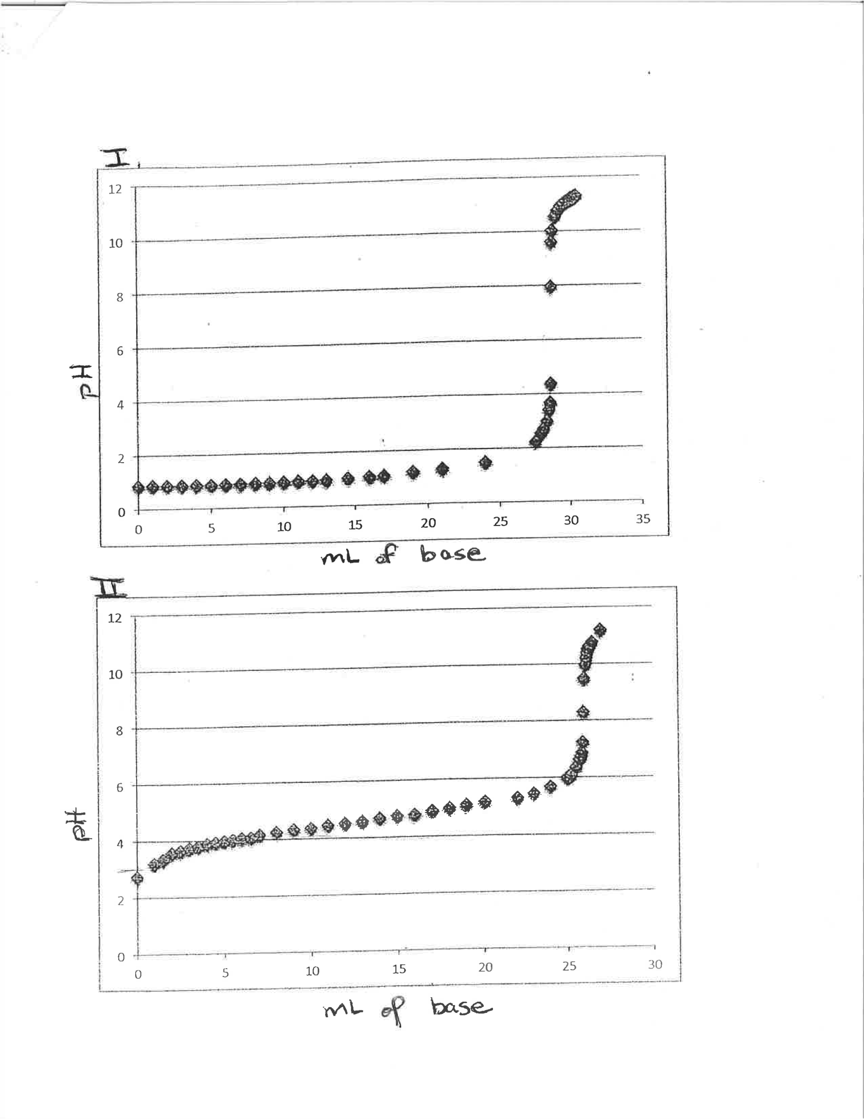
0.003125*1000/25=0.125M
Figure Error! No text of specified style in document.:1

- What is the approximate pH of the equivalence point for curve I? ph =7

Equivalence point pH for Curve Ii:_ph=9____________________

- How doe the equivalence point pH of Curve II compare to that of Curve I?

The equivalence point ph for the curve 2 is higher than that of curve 1

- One curve is for a weak acid titrated with NaOH and the other is for a strong acid titrated with NaOH. Identify which curve is for the weak acid and which is for the strong and support your choice.

Curve 1 is for strong acid because its equivalence point ph is at 7.curve 2 is for weak acid since its equivalence point ph is above 7 ie 9

- Using the curve for the weak acid, determine the approximate Ka value.
Ph=-log[h₃o⁺]
=-log[0.125]
Ph=0.903
Ka=10^{-kpa} =10^{-1.96}
0.01096

